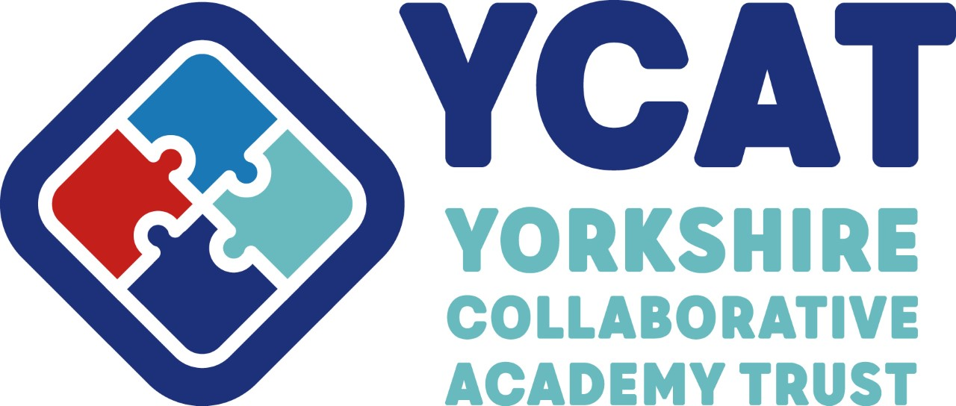

Accessibility Plan
2024-27

This Policy was adopted by

Yorkshire Collaborative Academy Trust
on 03/2024

Chair of Trustees: Mrs Jenny Baynes
Signature:
Frequency of review: | 3 years
To be reviewed by: | Full Board

REVIEW RECORD

Date of review | Reason for review | Date of next review
March 2024 | Cycle of review | March 2027

Cononley Primary School

Plan adopted and approved | Catherine Pickles
Position | Headteacher
Date | Autumn 2025
Reviewed
Reviewed

ACCESSIBILITY PLAN FOR CONONLEY PRIAMRY SCHOOL

Aims of the plan
The purpose of this plan is to show how our school intends, over time, to continue to increase accessibility to the curriculum, the physical environment and written information, so that all pupils/students with or without a disability can take full advantage of their education and associated opportunities in the school community.
We define our disabled pupils as:
- Those with physical disabilities, including ambulatory, dexterity, visual and auditory difficulties as well as hidden disabilities such as diabetes and other chronic conditions.
- Those with learning, emotional, social, behavioural, communicational, interactional and mental conditions as well as hidden disabilities such as dyslexia and autism.

Objectives of the plan
- To ensure all disabled pupils/students are fully involved in school life and are making good progress.
- To identify barriers to participation and find practical solutions to overcoming these.
- To work with disabled pupils/students and their parents or carers to create appropriate provision, including education health and care plans where relevant.
- To increase the confidence, sensitivity and expertise of staff when teaching or supporting a wide range of disabled pupils/students.
- To meet the requirements of the Equality Act 2010 and the SEND code of practice 2015, as updated in 2022, in respect of disabled pupils/students.
- To reduce or eliminate where possible the barriers to adults with a disability, be they staff, parents, carers, governors or other users, to ensure their full potential in the life of the school and enable full use of the facilities available.
- To monitor recruitment procedures to ensure that individuals with disabilities are provided with equal opportunities.
- To provide appropriate support and provision for employees with disabilities to ensure they can carry out their work without barriers.
- To undertake reasonable adjustments to enable staff to access the workplace.

The Equality Act 2010
Compliance with the Equality Act is consistent with our school aims and equal opportunities policy as well as our SEND policy.
The governing board has full regard to the Equality Act 2010 when carrying out their duties and responsibilities.
All those who work in the school as employees or volunteers recognise their duty under the Equality Act 2010:
- Not to discriminate against disabled pupils in admissions, suspensions or exclusions, or in the provision of education and associated services.
- Not to treat disabled pupils less favourably.
- To take reasonable steps to avoid putting disabled pupils at a substantial disadvantage.
- To publish an accessibility plan.

Key staff and governors
- The member of the senior leadership team with oversight of special educational needs and disabilities is Catherine Pickles.
- The lead member of staff is the SEND co-ordinator Kerrie Davis who is responsible for
- The special needs register.
- The welfare of all SEN and disabled pupils/students.
- Appropriate training for staff.
- Ensuring that the accessibility plan is implemented.
- Monitoring its effectiveness in meeting disabled students’ needs.
- Each year group has a named member of staff whose particular responsibility is SEND.
- All teaching and support staff involved in the teaching and learning of SEND pupils receive regular specialist training as part of our CPD programme.
- A named governor Julie Cawood is responsible for ensuring that the governing board has a termly update on SEND pupils at a full board meeting and an annual report on the improvements achieved for disabled pupils under the accessibility plan.

Our plan is based on the three main tenets of the DfE statutory advice as updated in 2022

Increased access to the curriculum
Ideally, all areas of the curriculum should be available to all pupils/students, regardless of their disability. We make every effort to educate students with disabilities alongside their peers in a mainstream classroom setting. Where this is not possible the SEND co-ordinator consults with the student and their parents about proposed flexible alternative arrangements.
The school curriculum is regularly reviewed to ensure it is accessible to students of all levels and abilities and supports the learning and progress of all students as individuals. This includes learning outside the classroom through activities such as after school clubs, leisure and cultural activities and school visits.
Areas on which we intend to concentrate in 2025 – 2027 include:
- Better early identification of the needs of disabled pupils/students and staff awareness of these.
- Regular training of staff on aspects of SEN and disability in the school and developing appropriate teaching and learning strategies.

- Embedded mechanisms to listen to views of SEND pupil/students and their parents/carers and consider them in all aspects of school life.
- Specific specialist intervention where needed for all SEND pupils.
- Specialist advice from other professionals.
- Special access arrangements for internal/external exams.
- Access to digital and audio-visual material and equipment.

Improved access to the physical environment of the school
The school carries out an accessibility audit every three years in advance of reviewing this policy. The audit is carried out by the governors’ resources committee as part of our regular safeguarding tours of the school.
Teachers are given advice on how to move and arrange furniture and how to manage lighting, noise and visual stimulus, etc. We also give attention to how pupils/students’ needs can be met on school journeys and visits.
Areas on which we intend to concentrate in 2025-2027 include:

- Customised furniture and equipment.
- Ensuring that the environment (classroom displays) is neutral and does not cause visual overwhelm
- Providing varied outdoor spaces so that some areas are quiet
- Providing alternative quiet, structured spaces at lunchtimes and playtimes
- Providing a nurture space to support pupils with SEMH.

Improved delivery of information to disabled pupil/students
Teachers and TLAs consider the needs of each disabled pupil/student and provide accessible learning resources for them. The increased use of interactive whiteboards and other digital technology have diversified the ways in which all pupils/ students received information.
Areas on which we intend to concentrate in 2024-2027 include:
- Providing electronic resources and software to support visual impairment
- Raising awareness of font sizes and page layout for pupils with visual impairments.
- Readers and scribes in examinations.
- Coloured overlays for texts.
- Soft ware to support children with literacy difficulties (reading and writing)
- Additional tactile resources.

Staff and other adult users with disabilities
The governing board recognises its responsibilities towards employees with disabilities (see above page 3).
Many of these improvements will also benefit disabled adults associated with the school as well disabled family members of pupils, staff and governors. They will also enable more disabled adults to have access to the school premises through wider use.

Review
The accessibility plan has the status of a policy of the governing board and must be reviewed every three years. The views of disabled students and adults will feed into the review and the accessibility audit.

 | Accessibility Plan: Improving Access to the Curriculum
Target | Strategy | Outcome | Timeframe
Early Identification of Need | Head teacher/Curriculum Leaders/SENCO to oversee and monitor the use of a variety of assessments (see SEND Policy and Information Report) to support the early identification of SEND | Early identification enables pupils to receive appropriate support. | Ongoing
Enabling Environments (nurture, low stimulation, quiet spaces) | Head teacher/Curriculum Leaders/SENCO to oversee and monitor the learning environments to support needs of all pupils | Environments have a positive impact and support pupils to be ready for learning. | Ongoing
Adaptive Teaching | Head teacher/Curriculum Leaders/SENCO to monitor quality of adaptation and provision for pupils with SEND. | Adaptive reachong and resources support all pupils, and particularly those with SEND, to achieve in line with their peers. | Ongoing
Bespoke resources and Assistive technology | Head teacher/Curriculum Leaders/SENCO to monitor use of bespoke resources and assistive technology to support specific needs (highlighted on POP) | Bespoke reources and assistive technology are used in line with POP and have an impact on learning | Ongoing
Interventions | Head teacher/Curriculum Leaders/SENCO to audit current interventions and their success/impact on progress. Provision mapping to be used across all year groups. | Interventions have the positive impact and support pupil catch-up | Ongoing
High Quality Teaching | Head teacher/Curriculum  Leaders/SENCO to carry out an audit of resources and High QualityTeaching to ensure that lessons are planned to meet the needs of all pupils in the class. | All pupils’ needs are catered for in order to help them know more, remember more and do more. | Ongoing
Staff training in supporting pupils with SEND – focus on EEF 5 a Day approach | SENCO deliver training where possible. Identify gaps in knowledge and seek external advice if necessary | Specific needs are catered for in order to help pupils know more, remember more and do more. | Ongoing

